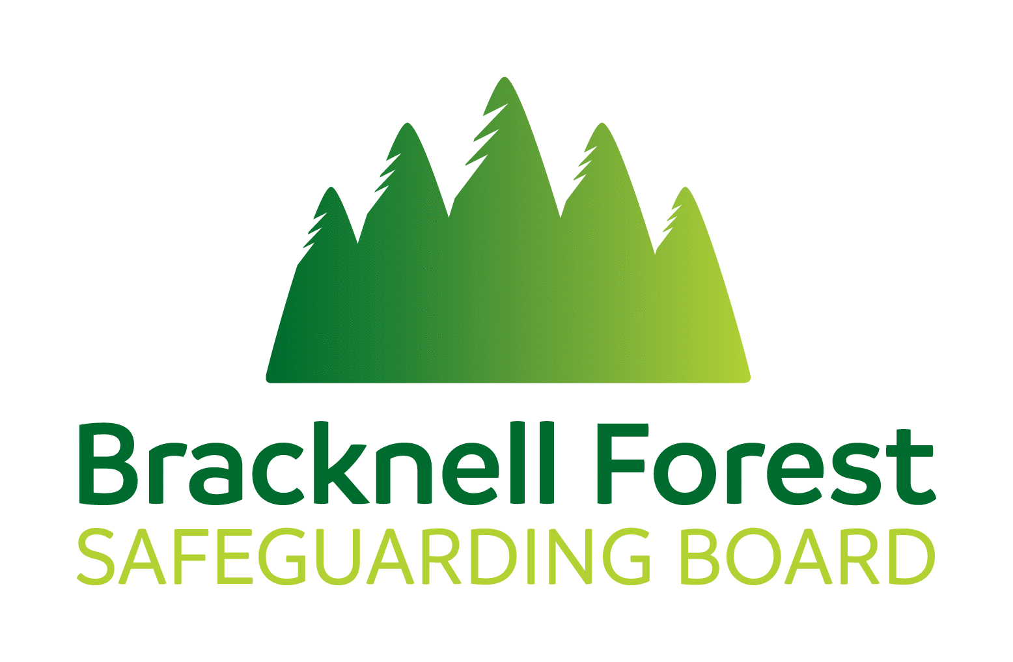

SB1 - Children/Adults Rapid Review request form

CONFIDENTIAL

Any agency can inform Bracknell Forest Safeguarding Board (BFSB) of any incident they think should be considered for a Safeguarding Adults Review (SAR) or a Local Child Safeguarding Practice Review (LCSPR. However, this process can also be used where cases do not meet these criteria but appear to offer an opportunity for learning in respect of multi-agency working.

Before notifying BFSB, professionals should discuss the case with their agency’s nominated manager to ensure they are basing their decision on all the available information and that they are aware and/or endorse the notification. If you need advice completing this form, please contact us.

Information considered within this review remains restricted until the Rapid Review panel have determined the arrangements for notifying individuals and/or family members. As a result, individuals/family members should not be made aware of this process.

A referral should be made as soon as possible after the serious incident occurs.

Details of case:

Name of child/adult:

Details of other individuals involved should be added in Section 1.2

Date of Referral:

Details of individual/ organisation requesting the Rapid Review:

Name
Position/Designation
Organisation
Address
Contact telephone
Contact email
Authorising Manager
Position/Designation
Contact telephone
Contact email
Date of request

Section 1: Brief overview of child and family composition

  - Child/adult’s Details
Name of Child/Adult (including any aliases)
Date of Birth
Home address
Other relevant addresses
Gender
Ethnic Origin
Religion/Belief
Disability
Other Protective characteristics (to include gender reassignment / marriage/civil partnership / pregnancy & maternity / sexual orientation)
GP and practice details
NHS no.
Is the child/young person looked after, or a care leaver/previously looked after? (ignore for adults)
Is the individual subject to any form of safeguarding plan? (please give brief details)
Is the individual open to services provided by the local authority (please give details including name of lead practitioner
Date of Death or Serious Incident (please specify which)
Address of location of incident
Carer at time of incident (if applicable)
Is this case known to be the subject of a criminal investigation? (If so, who is the lead investigator?)
Is this case known to be the subject of a Coroner’s Inquiry? (If so, who is the key contact?)
Are there any safeguarding concerns for other individuals? Please provide details

1.2 Details of Family Members and any Significant Others

Name and Address | Relationship to individual | Date of Birth | Legal Status | Ethnic Origin

What action has been undertaken to safeguard and protect others linked/related to the individual?

1.3 Other agencies known to be involved (eg police/coroner/health agencies)

Agency | Contact Details: Address, Telephone and E-mail | Reason for involvement (include whether current or not)

Section 2: Background information

Please provide a brief outline of the case /incident:
Please include any specific areas of practice/multi-agency issues you wish to bring to the attention of the RR panel.

What learning do you think can be achieved through a review of this case?
In this section, we would ask that the author focusses on the learning related to their own agency and include any recommendations that have been made for improvement in practice/systems. Where the author wishes to make observations about other partner agencies involvement, this should be addressed in the section above and avoid making recommendations on their behalf.

To what extent has the Covid-19 pandemic impacted either on the circumstances of the individual or on the capacity of the services to respond to their needs?

If appropriate, has the case been notified to LeDeR (Learning Disabilities Mortality Review)
If so, on what date and by whom

2.1 Chronology

Please use the chronology table below to provide a brief outline of key events.

Date and Time | Event
DD.MM.YY – HH:MM
DD.MM.YY – HH:MM
DD.MM.YY – HH:MM
DD.MM.YY – HH:MM
DD.MM.YY – HH:MM
DD.MM.YY – HH:MM
DD.MM.YY – HH:MM

2.2 Additional Information

Please add any additional information you think may be relevant and may assist decision making:

The above information should be informed by a discussion with your agency’s nominated manager

Please submit this form to:

BFSB @bracknell-forest.gov.uk
Or by post to:
Bracknell Forest Safeguarding Board
Time Square, Market Street,
Bracknell RG12 1JD

