Rapid Review Flowchart*
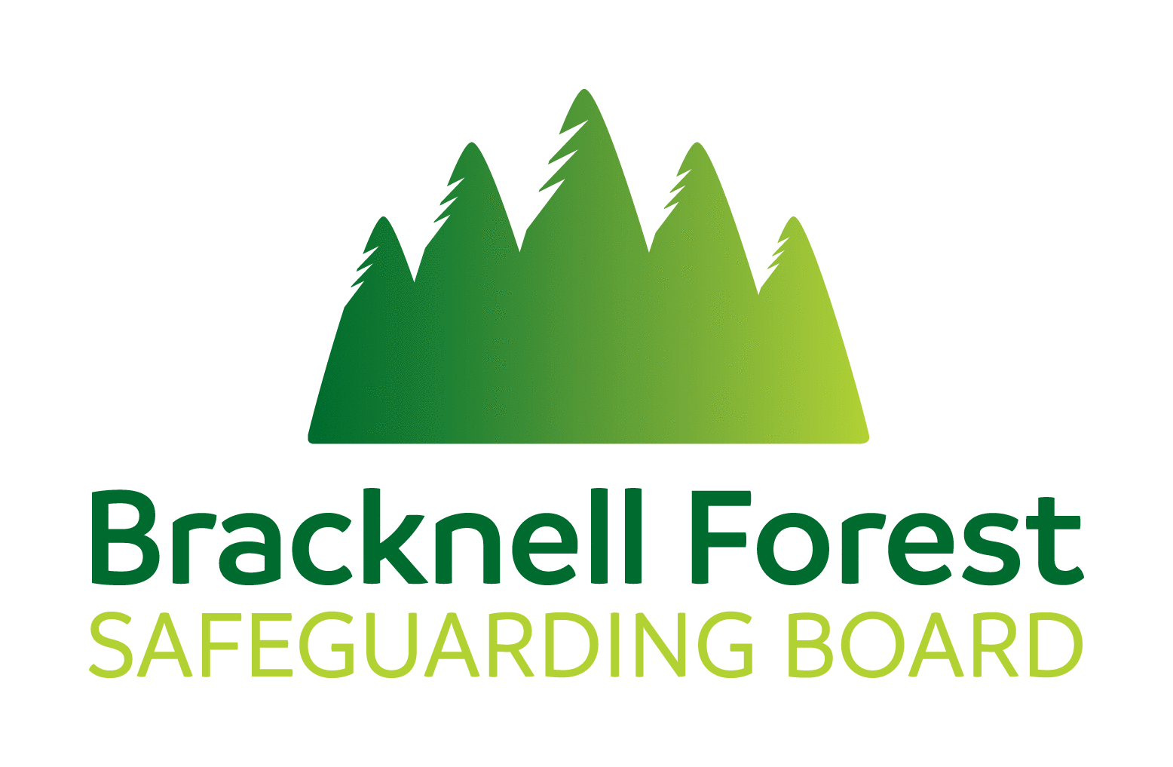
Rapid Review Flowchart

Any agency can notify the SB of a serious incident by using the Case Review Referral Form SB1. Notifications should be made promptly and given priority over an organisation’s internal processes.
Following notification of a Rapid Review the following process should be followed.

Within 2 working days of referral | Safeguarding Partners consider initial information (Form SB1). Cases may result in:  - no further action (NFA),  - a single agency review to identify learning but that may involve another agency/ies where appropriate.  - a rapid review is required, information should be gathered and:  - outline details (SB2) should be sent to relevant agencies with the requirement that they provide additional information  - a date is set for a Rapid Review Meeting

Within 5 working days of form SB2 being issued | Partners respond to request for additional information. Completed forms are returned to the Business Unit and shared with those attending the Rapid Review meeting along with SB1 and any LA notification.

Between 7 and 13 working days of initial notification | The Rapid Review meeting is convened, with the authors of SB2 in order to:  - review the facts about the case presented in the documentation  - agree any immediate action  The statutory partners will then:  - consider the case against the criteria for a SAR/LCSPR or LLR/Discretionary review  - decide whether a single-agency practice review or other learning review should take place  - complete the Rapid Review meeting template and record their decision and make any recommendations.

Within 15 working days of the initial notification | Details of the Rapid Review meeting are sent to Safeguarding Partners, ICS and the Chair of Case Review subgroup informing them of any decisions reached to commission a:  - LLR/Discretionary review  - SAR  - LCSPR (subject to approval of the National CSPR Panel). It is important to remember that there are significant differences between adults and children in regard to the decisions made and /or the next steps.  Information gathered during the RR may also be shared with the Community Safety Partnership (CSP) who will, in turn, consider the necessity for a Domestic Homicide Review (DHR) to be undertaken.

* Strict adherence to timescales does not apply to adult cases

Please note that the pan Berks Child Death Overview Panel (CDOP) and the Learning Disabilities Mortality Review Programme (LeDeR) will also help provide important learning which informs safeguarding practices across the borough. These processes are distinct to those relating to the Rapid Review and independently facilitate a review of cases meeting the

